Unit 2

1.5 I can describe how copyright and other constraints can affect the website

The use of copyright laws and the problems you may run into when creating something can be tricky but knowing which rules you need to follow make it easier.

**Plagiarism:** this means that you can not copy something word for word, like a book’s story that is published by a famous author like Roald Dahl or Giovanna Fletcher, you couldn’t publish a book under a different name but have either the whole or portions of their work in your book as that would be plagiarism. You can’t also make a video for a video sharing platform and copy a scene from a famous play or movie and get any profit off the video.

**Resource owners permission**: finding such things like photos and music on certain sites like Soundcloud or Flickr then emailing the owner of the thing (music or photo etc.) asking them for permission of use for the thing you want to use on your project is a good way to ensure that you have the right copyright licences for the piece of art. The owner of the thing you want to use may give you the permission on the piece of art after emailing them and then you would save the email or paperwork they sent over with them granting you permission as proof of licensing. Most owners (like big companies that earn a lot of money such as Microsoft and Sony) will make you pay a fee for lending the thing you want to use.

**Open source resource**: some websites like Soundcloud etc. are places where people share their piece of art with other people on the website and most of them let you use their things without having to pay a fee or have any limitations on what you can do with the thing you want to use, like remixing it or changing it in any way. Some might not even need you to email the owner because they have expressed on the page you are downloading it from that it is free to use in the Public Domain, screenshotting them or ensuring you have proof of this notice is helpful though.

Intellectual property: Some things like a company name or slogan will have a trademark or something similar attached to it which protects them from having any other person using that company name or slogan. Nike is an example of a company that has a trademark on their name. Some people try to trademark things like the word cheese and the courts may not accept it because it is something that cannot be trademarked or owned by anyone. If someone made a new type of cheese and copyrighted the flavour as their creation then that is allowed and they will have rights over that cheese flavour.

**My evidence of copyright usage on my website**:



I use the above image on my Chubu page on my website and it has the following licensing rules attached to it: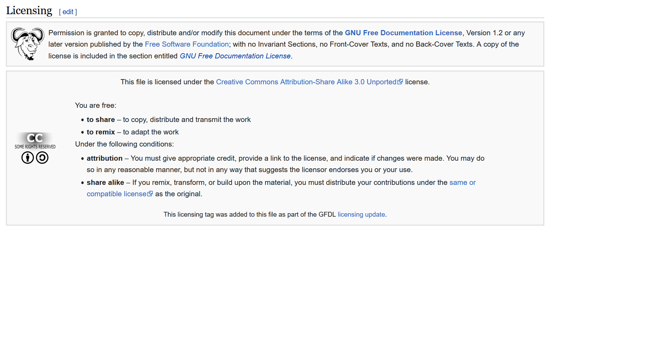

Which means I do not need to ask for permission for use of the photo or pay them any royalties if I was getting revenue off the photo on merchandise etc.